Motivators: The Individualistic Motivator

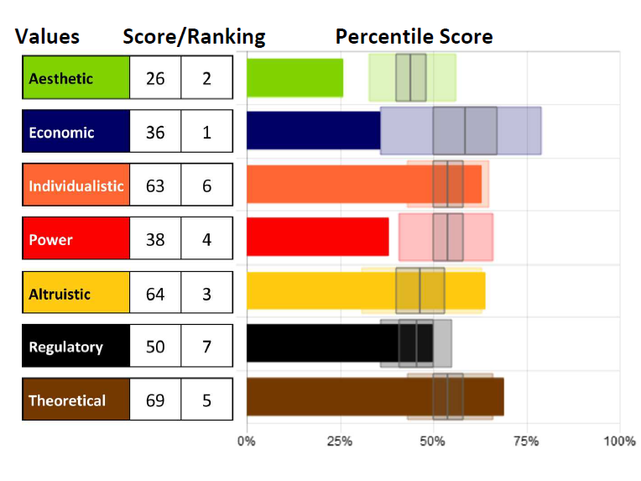
Knowing our specific level of
motivation can be crucial to
helping us understand what
drives our beliefs and actions so
we can bring them into
alignment.

Remember that although we can
explore each motivation
individually, they cannot be
separated. They can only be
distinguished; however, all
motivators integrate to influence us.

The Individualistic Motivator - the drive to be seen as unique and
independent

The Individualistic driver is one’s need to be seen as autonomous,
unique, and to stand apart from the crowd. This is the drive to be
socially independent and have opportunity for freedom of personal
expression.

Those scoring higher in this motivator need to be noticed as special –
in a jar of pennies, this person would be a red one. The higher the
score, the more this person must prove they are different; low scores
are more confident and secure, not seeking external validation or
attention.

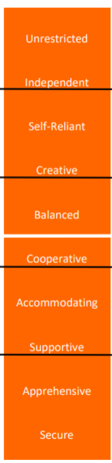
Using this descriptor scale, you can identify a key component to each person’s score in this motivation, as well as see how the scores range from Very Low to Very High, noted by the black lines between each set of descriptors. Each word represents 10 points of 100 on the scale (example: Supportive people score between 20-29, Independent people score between 80-89 in this dimension).
The white line indicates 50%, perfect balance between high and low in the motivation. Those who score closer to 50% will be situational in applying this motivator. Moving further from that line (high or low) indicates which areas are the more influential.

Whether scores are high or low, the motivators with the furthest distance above or below 50% (above or below “perfect balance” in the center) will be the highest influencers leading to the greatest impact on the decisions being made.

Strengths and Limitations

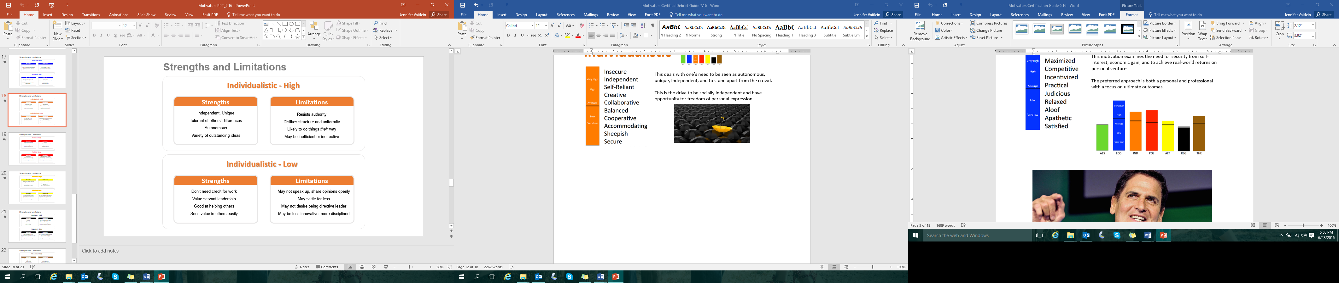

- What drives you in this motivation?
- How can that be helpful and productive for you?
- How can that limit you?

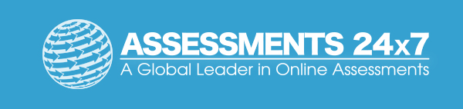Assessments 24x7 LLC 5927 Balfour Court, Ste. 103 Carlsbad, California 92008 USA (206) 400-6647

